- Upload dataset ( Infectious Skin Lesion Dataset) on kaggle
- Import python notebook (infectious-skin-lession-classification.ipynb)
- Go to Edit option
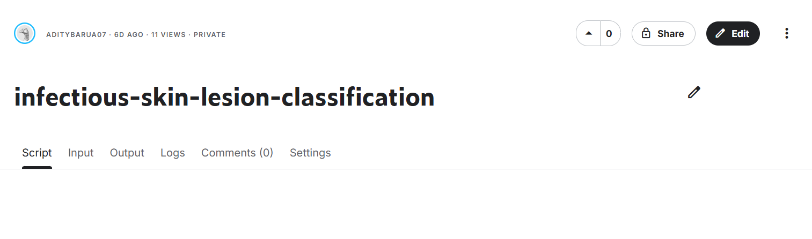
- Click on “Add input” and connect the dataset to the cnotebook.
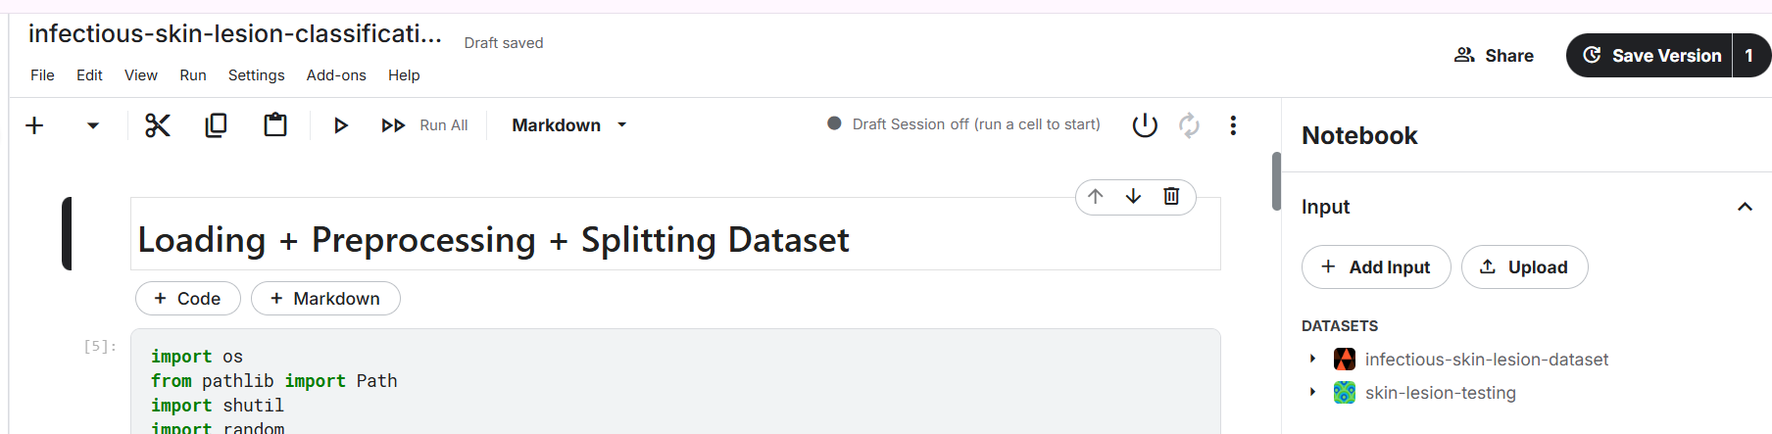

- Turn on GPU
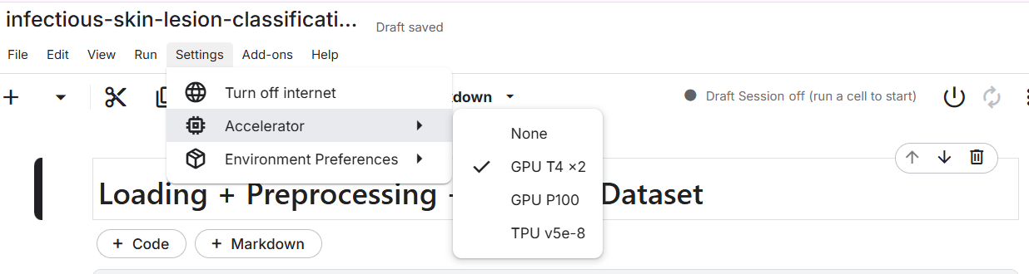
And, run the code.

